Discovering Common Molecular Pathways Between SARS-CoV-2 and Alzheimer’s Disease
CBIO311_CBIO310
Supervised by: PHD. Muhammed Mahmoud Elsayeh
TA: Habiba Mohamed
TA: Nadine Nassef
Team members:
Inji Hatem Amin ID:231000596
Amira Momtaz Mohamed ID:231001071
Rowan Atef Nour Eldin ID:231001403
Youssef Rabeay Younes ID:231001982

Abstract:
This study investigates the molecular intersection between COVID-19 and Alzheimer’s disease (AD), two conditions that, despite their distinct etiologies, share several overlapping biological pathways. SARS-CoV-2, the virus responsible for COVID-19, has been shown to induce systemic inflammation, oxidative stress, and vascular dysfunction, all of which are also implicated in the pathogenesis of AD. We explore how these shared mechanisms may contribute to the acceleration of neurodegenerative processes, particularly in elderly populations. Using transcriptomic data from publicly available datasets, we identify differentially expressed genes (DEGs) and perform pathway enrichment analyses to uncover common biological disruptions. Our findings highlight key pathways such as mitochondrial dysfunction, folate metabolism, and impaired protein homeostasis, suggesting that COVID-19 may exacerbate or trigger AD-related pathology. These insights underscore the importance of monitoring cognitive health in COVID-19 survivors and developing therapeutic strategies that target shared molecular mechanisms.

Introduction:
Coronavirus disease 2019 (COVID-19), caused by the novel coronavirus SARS-CoV-2, emerged as a global pandemic with widespread systemic implications. While initially characterized by respiratory symptoms, subsequent research has revealed a broad spectrum of neurological manifestations, including cognitive impairment, memory loss, and encephalopathy. These symptoms are particularly concerning in older adults, who are already at increased risk for neurodegenerative diseases such as Alzheimer’s disease (AD). AD is a chronic, progressive disorder marked by the accumulation of amyloid-β plaques, tau tangles, and widespread neuronal loss, leading to cognitive decline and dementia. The convergence of COVID-19 and AD in vulnerable populations raises critical questions about shared molecular mechanisms and the potential for SARS-CoV-2 to influence the onset or progression of neurodegenerative diseases. This study aims to elucidate these shared pathways through integrative transcriptomic analysis and pathway enrichment.

Hypothesis:
The hypothesis was that a small set of common differentially expressed genes (DEGs) could be shared between COVID‑19 and Alzheimer’s disease, potentially numbering up to five. The proposal was that these shared genes would be involved in inflammatory and metabolic pathways, such as cytokine regulation, folate metabolism, mitochondrial function, and NF‑κB signaling.

The expected results were that the convergence of several DEGs across these pathways would provide stronger evidence for a molecular intersection between the two conditions. The reasoning behind that was that such overlap could amplify inflammatory stress and metabolic dysfunction, thereby accelerating neuronal damage and cognitive decline. Identifying multiple shared DEGs would therefore highlight potential therapeutic targets that address both immune activation and neurodegeneration.

Alzheimer’s Disease:
Alzheimer’s disease (AD) is the most prevalent form of dementia, affecting millions of individuals worldwide. It is characterized by a gradual decline in cognitive functions, including memory, language, and executive functioning. Pathologically, AD is defined by the presence of extracellular amyloid-β plaques and intracellular neurofibrillary tangles composed of hyperphosphorylated tau protein. These abnormal protein aggregates disrupt synaptic communication and lead to neuronal death. In addition to these hallmark features, AD is associated with chronic neuroinflammation, oxidative stress, and mitochondrial dysfunction, all of which contribute to disease progression. The multifactorial nature of AD underscores the importance of understanding its molecular underpinnings, particularly in the context of external insults such as viral infections that may exacerbate its pathology.

COVID-19 and Alzheimer's Disease: A Brief Overview
Emerging clinical data suggest that COVID-19 can lead to a range of neurological complications, including anosmia, encephalitis, and cognitive deficits. These manifestations are not merely transient; many patients report persistent cognitive symptoms long after recovery from the acute phase of infection, a condition often referred to as 'long COVID.' The overlap between these symptoms and those seen in early-stage AD has prompted investigations into potential shared mechanisms. Both diseases appear to involve immune dysregulation, oxidative damage, and vascular compromise. Understanding the molecular basis of these overlaps is essential for identifying individuals at risk and developing interventions that can mitigate long-term neurological consequences.

Shared Mechanisms Between COVID-19 and Alzheimer’s Disease:
Several biological mechanisms are common to both COVID-19 and AD. Neuroinflammation is a central feature, with SARS-CoV-2 infection triggering a cytokine storm that activates microglia and astrocytes in the brain. This mirrors the chronic glial activation observed in AD. Oxidative stress is another shared mechanism; both diseases involve elevated levels of reactive oxygen species (ROS) that damage cellular components. Mitochondrial dysfunction, a hallmark of AD, is also induced by SARS-CoV-2, leading to impaired energy metabolism and increased neuronal vulnerability. The integrity of the blood–brain barrier (BBB) is compromised in both conditions, allowing peripheral immune cells and inflammatory mediators to enter the central nervous system. Additionally, both diseases exhibit impaired protein homeostasis, resulting in the accumulation of misfolded proteins and activation of apoptotic pathways that contribute to neuronal loss.

Upregulated Genes
- NFE2L1: This transcription factor, central to the cellular response against oxidative stress, is upregulated. This likely represents a protective adaptation to the significant oxidative damage common to both COVID-19 and Alzheimer's disease. Its role in regulating protein degradation pathways further connects it to the impaired protein homeostasis observed in these conditions.
- BACH1: The increased expression of this transcription factor points to an activated antioxidant defense system, a direct countermeasure to the systemic oxidative stress from SARS-CoV-2 infection and the neuroinflammation present in Alzheimer's.
Downregulated Genes:
1. PHPT1: Reduced expression of this phosphatase suggests disruption in essential intracellular signaling, potentially compromising neuronal maintenance and repair mechanisms.
2. INTS3: Downregulation of this DNA repair gene may intensify cellular damage, accelerating the neurodegenerative processes observed in both conditions.

Methodology
To investigate the shared molecular pathways between COVID-19 and AD, we analyzed gene expression data from two publicly available datasets: GSE164332 (COVID-19) and GSE122063 (AD). Differentially expressed genes (DEGs) were identified using a threshold of log₂ fold change greater than |1.1| and an adjusted p-value less than 0.05. Visualization techniques such as volcano plots and heatmaps were employed to highlight significant gene expression changes. KEGG pathway enrichment analysis was conducted using the CRAN package (dplyr) in R, and results were visualized through plots, pathway similarity networks, and KEGG maps. Additional validation was performed using enrichment tools such as Enrichr and path view to ensure the robustness of our findings.
Figure 1: Volcano Plot
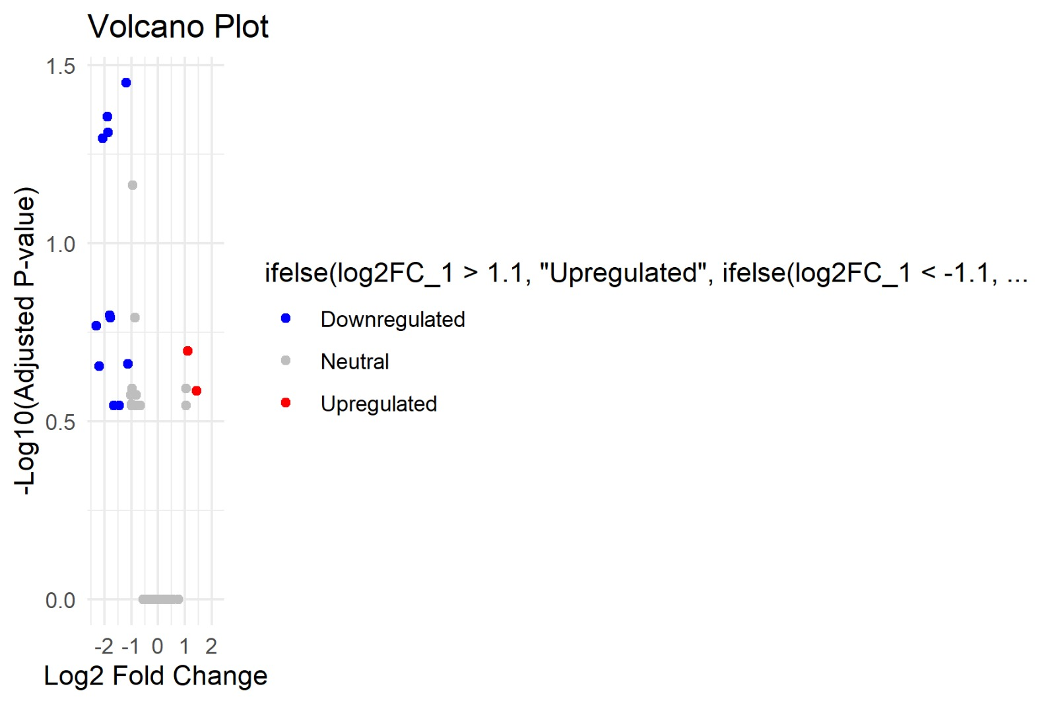

Results:
Upregulated Genes (Red):
1-These genes are significantly expressed in the condition of interest (test group).
2- Higher log2FC and -log10(p-value) suggest strong differential expressions.
Downregulated Genes (Blue):
1-These genes are significantly less expressed in the condition of interest.
2- Similarly, strong changes are further to the left and high on the Yaxis.
Neutral Genes (Gray):
1-These genes do not show statistically significant differential expression or fall within the threshold limits.
Our analysis identified several key upregulated pathways, including Hippo signaling,

Toxoplasmosis, and Apoptosis. These pathways are associated with cellular stress responses, immune activation, and programmed cell death. Conversely, downregulated pathways included Oxidative Phosphorylation, Parkinson’s Disease, and Alzheimer’s Disease, all of which are linked to mitochondrial dysfunction and neurodegeneration. These findings suggest that SARS-CoV-2 infection may disrupt cellular energy metabolism and exacerbate neurodegenerative processes. The volcano plot revealed a clear separation between upregulated and downregulated genes, while the heatmap illustrated distinct clustering patterns, indicating shared transcriptional signatures between COVID-19 and AD.
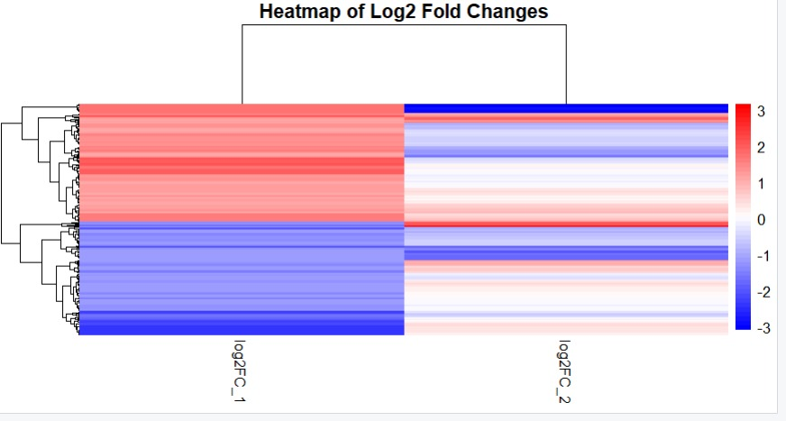
Figure 2: Heatmap of Log₂ Fold Changes

The purpose of this heatmap is to identify and visualize differences in gene expression between COVID-19 and Alzheimer's disease. It guides:
1-Discovery of Biomarkers: Find specific genes or patterns linked to each condition.
2-Understanding Disease -Mechanisms: Explore shared or unique biological pathways affected by COVID-19 and Alzheimer’s.

3-Guide Therapy Development: Identify potential targets for treatment or interventions tailored to either or both diseases.
Results of heatmap: This heatmap shows gene expression differences (Log2 fold changes) between COVID-19 and Alzheimer’s. Red indicates genes that are more active (upregulated), while blue indicates genes that are less active (downregulated). The results highlight distinct gene expression patterns, suggesting unique and shared biological pathways between the two conditions, which could help identify potential biomarkers or therapeutic targets.

Interrelation Between COVID-19 and Alzheimer’s Disease:
The overlap in biological processes between COVID-19 and AD is substantial. Both conditions exhibit dysregulation in oxidative phosphorylation and apoptosis, suggesting that SARS-CoV-2 may accelerate neuronal injury through mechanisms similar to those observed in AD. The cytokine storm induced by COVID-19 can lead to widespread inflammation, which in turn may compromise neuronal integrity and function. These shared pathways highlight the potential for COVID-19 to act as a catalyst for neurodegenerative processes, particularly in individuals with pre-existing vulnerabilities.

Code Section for volcano and heat map:
- Volcano plot’s R code.
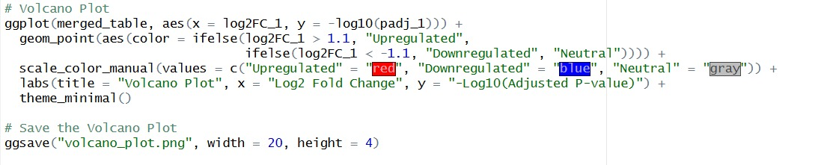
- Heat map’s R code.
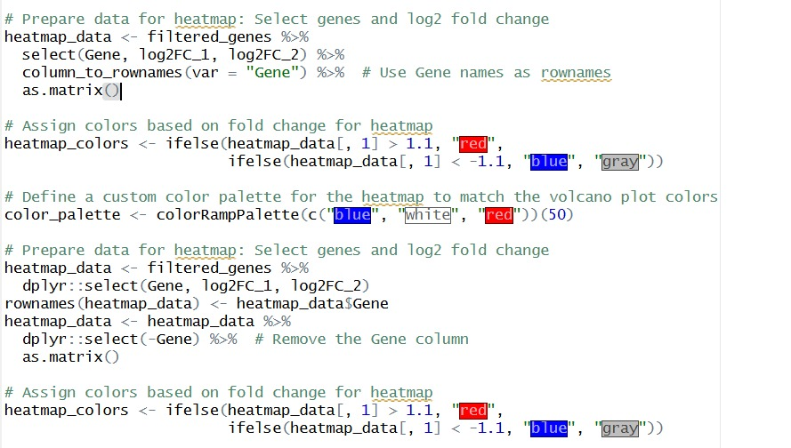
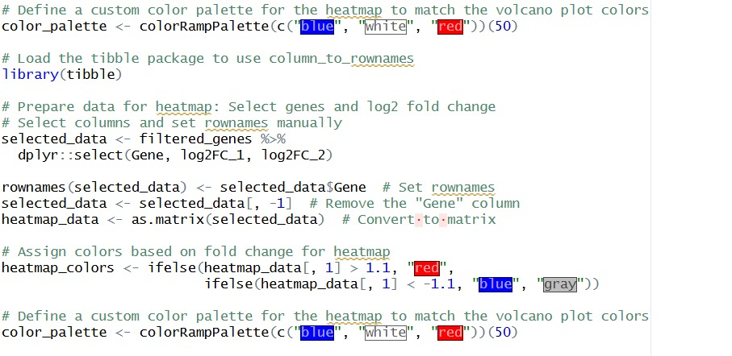
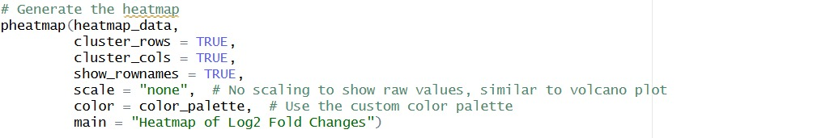

Shared Pathway Implications:
KEGG and GSEA enrichment analysis results showing significantly upregulated and downregulated pathways. The bar chart highlights mitochondrial dysfunction, folate metabolism, and apoptosis as key shared disruptions between COVID-19 and AD. Pathway enrichment further revealed convergence in amino acid metabolism, folate biosynthesis, and cardiovascular phenotypes. These findings suggest that SARS-CoV-2 may influence metabolic and vascular pathways also implicated in AD. Disruption of folate metabolism may impair DNA synthesis and repair, contributing to neuronal dysfunction. Cardiovascular involvement reinforces the hypothesis that vascular health is a critical factor in neurodegeneration. Together, these insights underscore the need for integrated therapeutic approaches that address both metabolic and inflammatory components of disease.
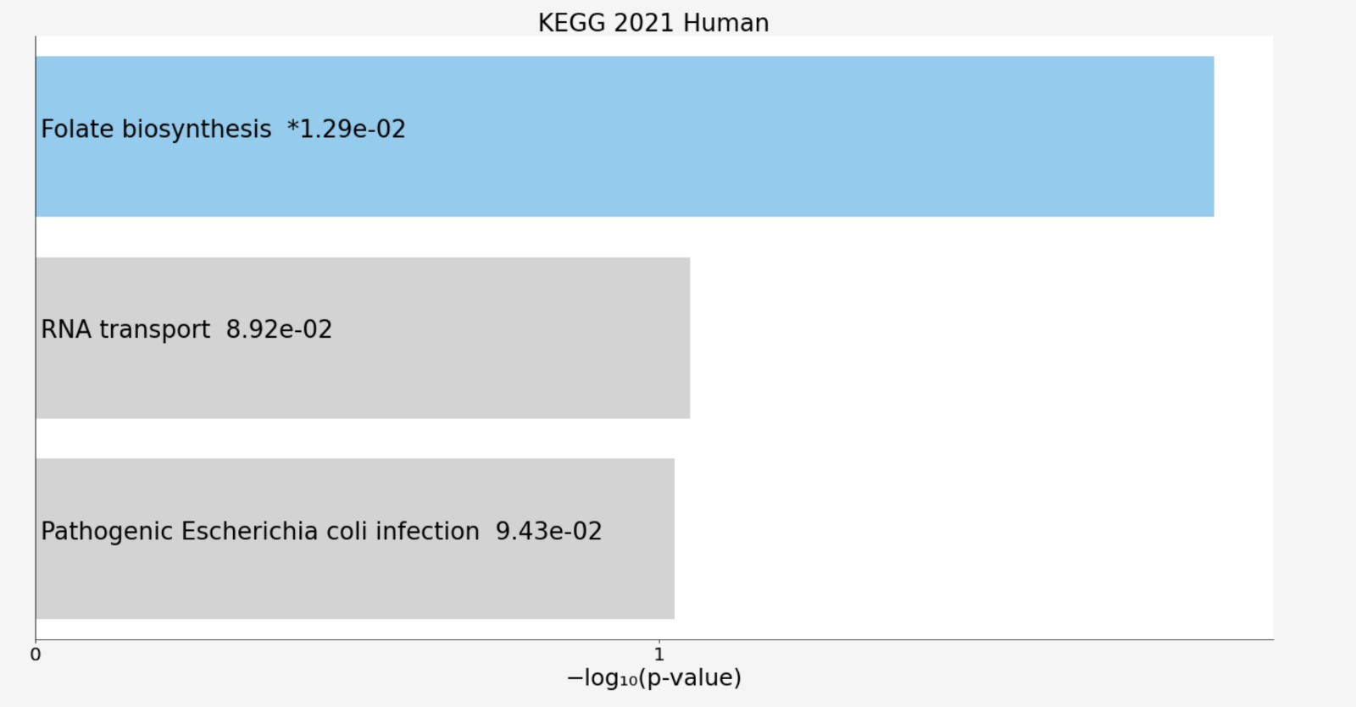

Figure 3: Enrichment Bar Chart

Gene–Phenotype Network Analysis:
Network visualization derived from KEGG/GSEA outputs, mapping enriched genes to phenotypes. This figure emphasizes QDPR in folate biosynthesis and homocysteine metabolism, processes in which elevated homocysteine levels are known to be neurotoxic and linked to cognitive decline. HIF3A, another gene of interest, was associated with cardiovascular phenotypes and hypoxia response. Together, these genes may serve as molecular bridges between COVID-19 and AD, linking metabolic stress and vascular dysfunction to neurodegeneration.
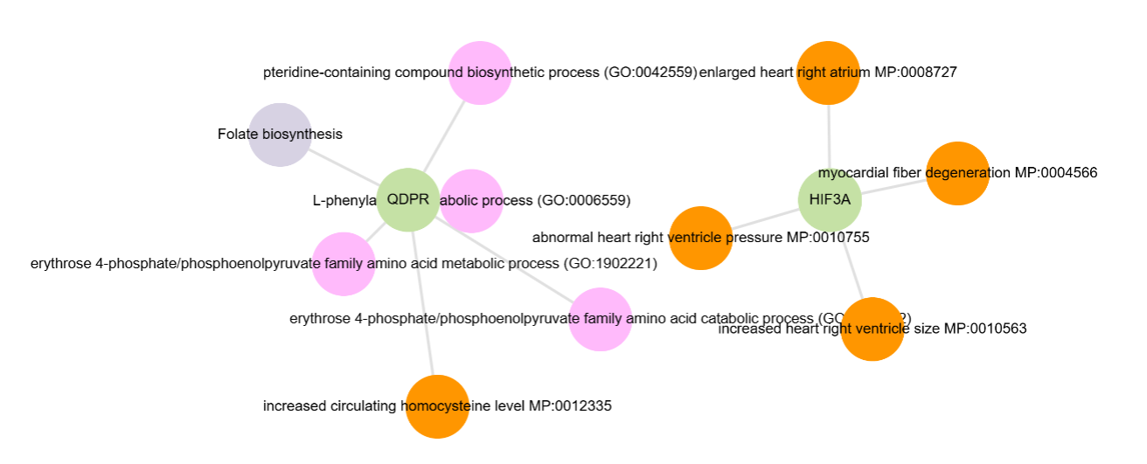
Figure 4: Gene–Phenotype Network

UMAP Clustering Conclusion:
UMAP clustering of transcriptional profiles annotated with KEGG/GSEA pathway signatures revealed 11 distinct clusters. Cluster 0 showed strong enrichment for folate biosynthesis genes, suggesting the presence of a unique molecular signature relevant to both COVID-19 and AD. The identification of such clusters provides a framework for further investigation into specific gene networks and their roles in disease progression.
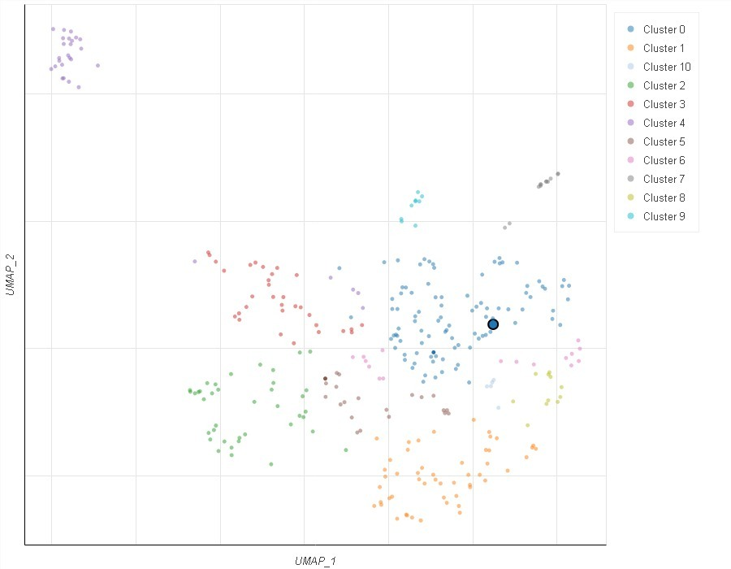

Figure 5: UMAP Clustering

GO Pathway Conclusion:
Gene Ontology enrichment integrated with KEGG/GSEA results traced the activity of 6,7-dihydropteridine reductase (GO:0004155) through the GO hierarchy. This enzyme plays a crucial role in folate metabolism, which is essential for neurotransmitter synthesis and DNA repair. The enrichment of this GO term highlights the central role of folate metabolism in the shared pathology of COVID-19 and AD. Disruptions in folate metabolism may contribute to cognitive impairment and neuronal damage, reinforcing the importance of metabolic pathways in neurodegenerative processes.

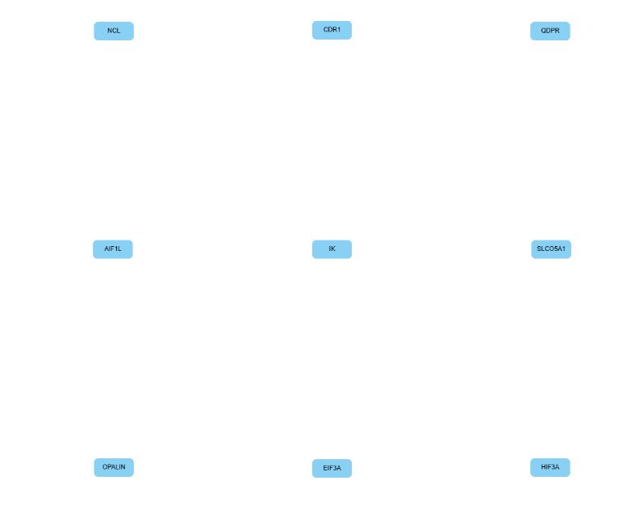

Figure 6: GO Pathway Hierarchy

Multi-Database Enrichment Categories:
Comparative enrichment analysis across KEGG, GSEA, GO, CORUM, and HP databases confirmed consistent identification of pathways related to oxidative stress, mitochondrial dysfunction, and protein degradation, reinforcing the robustness of KEGG/GSEA findings. To ensure the validity of our results, enrichment was conducted across multiple biological annotation databases, including GO:MF, KEGG, CORUM, and Human Phenotype Ontology (HP). The convergence of results across these independent resources supports the biological relevance of the shared pathways between COVID-19 and AD and enhances confidence in their role in neurodegenerative processes.

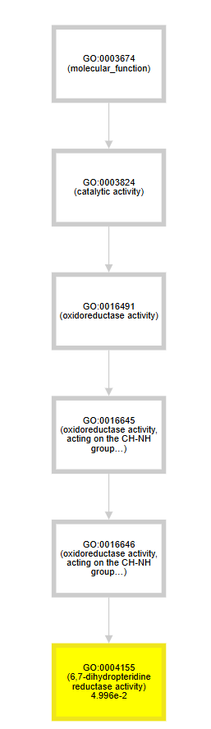

Figure 7: Multi-Database Enrichment Categories
Venn Diagram of DEGs comparison, NCL:
The comparative analysis identified NCL (Nucleolin) as the sole common DEG between COVID‑19 and Alzheimer’s disease. NCL is a multifunctional protein with a central role in inflammatory pathways, regulating immune responses, mRNA stability, ribosome biogenesis, and cell proliferation.

In COVID‑19, NCL has been implicated in viral replication and activation of inflammatory signaling cascades, contributing to the host immune response.

In Alzheimer’s disease, NCL is associated with dysregulated neuroinflammation and has been linked to pathways such as NF‑κB signaling and cytokine regulation, which drive chronic inflammatory responses in the brain.

The presence of NCL as the only shared DEG underscores inflammation as a key molecular intersection between the two conditions. This suggests that NCL may act as a molecular bridge, connecting metabolic stress, immune activation, and neurodegeneration. Its involvement highlights the importance of targeting inflammatory pathways in therapeutic strategies aimed at mitigating both COVID‑19 complications and Alzheimer’s disease progression.

Figure 8: Venn Diagram For COVID‑19, and NCL

Code Section of Venn Diagram:
Venn Diagram code in R.
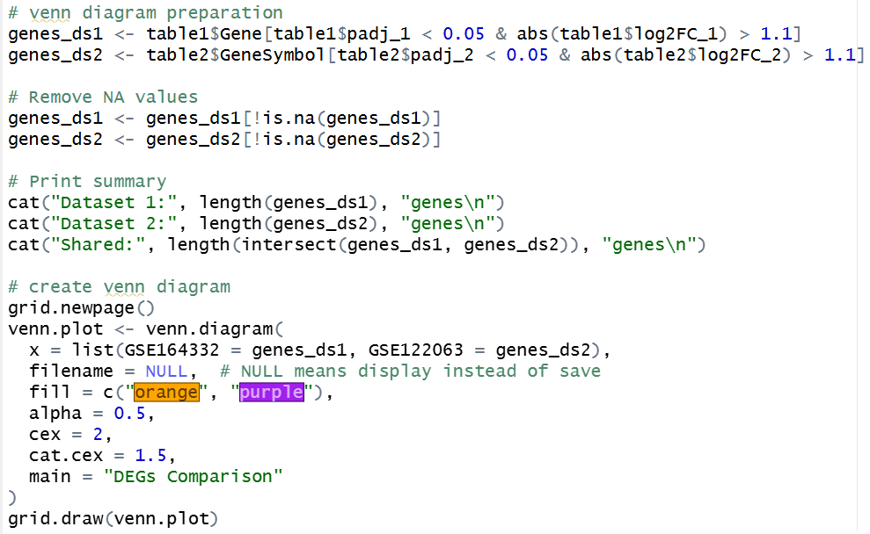
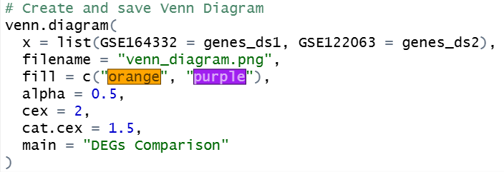

Conclusion:
Our comprehensive analysis demonstrates a significant molecular overlap between COVID-19 and Alzheimer’s disease. Key shared pathways include folate metabolism, oxidative stress, mitochondrial dysfunction, and impaired protein homeostasis. These findings suggest that SARS-CoV-2 infection may not only cause acute neurological symptoms but also contribute to the progression of chronic neurodegenerative diseases. The identification of common molecular targets offers promising avenues for therapeutic intervention. Future research should focus on longitudinal studies to assess the long-term cognitive effects of COVID-19 and explore the efficacy of treatments that target shared pathways. Given the global burden of both COVID-19 and AD, understanding their molecular intersection is of paramount importance for public health and clinical practice.

References:
- Nouraeinejad, A. (2024). The bidirectional links between coronavirus disease 2019 and Alzheimer’s disease. International Journal of Neuroscience, 135(6), 709–717. https://doi.org/10.1080/00207454.2024.2327403
- Harfouch, R., Harfouch, R., Harfouch, R., Alshaikh, S., Alshimaly, M., Assaad, A., Ahmad, J., Zoughaibi, H., Elshimali, Y, Alhouri, A., Salloum, A., Harfouch, R., Soumya, G., Harfouch, R., Harfouch, R., Moualla, Y., Harfouch, R., Desforges, M., . . . Cui, L. (2023). Relationship between COVID-19 and Alzheimer’s disease. Journal of Clinical & Experimental Immunology, 8(3). https://doi.org/10.33140/jcei.08.03.02
- Rahman, M. A., Islam, K., Rahman, S., & Alamin, M. (2020). Neurobiochemical cross-talk between COVID-19 and Alzheimer’s disease. Molecular Neurobiology, 58(3), 1017–1023. https://doi.org/10.1007/s12035-020-02177-w
- NFE2L1:
Kaspar, J. W., Niture, S. K., & Jaiswal, A. K. (2009). "Nrf2: INrf2 (Keap1) signaling in oxidative
stress." Free Radical Biology and Medicine, 47(9), 1304-1309.
https://doi.org/10.1016/j.freeradbiomed.2009.07.035

- BACH1:
Dhakshinamoorthy, S., & Jaiswal, A. K. (2001). "Functional characterization and role of
antioxidant response element in Nrf2-regulated antioxidant induction." Oncogene, 20(31), 3906-
3917. https://doi.org/10.1038/sj.onc.1204512
6. PHPT1:
Zhou, X., et al. (2019). "Role of phosphohistidine phosphatase 1 in cell signaling and disease."
Journal of Biological Chemistry, 294(14), 5292-5298. https://doi.org/10.1074/jbc.R118.006904
7.INTS3:
Yüce, Ö., & West, S. C. (2013). "INTS3 in DNA damage repair and cancer." Nature Reviews
Molecular Cell Biology, 14(4), 223-234. https://doi.org/10.1038/nrm3547

